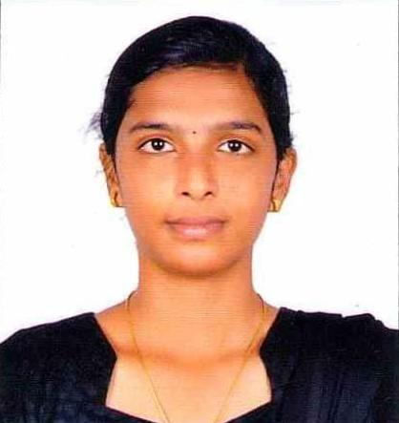**Kiruba Thangarasu**

Tel: +91 9384515849

Email: [kirubakiruba9185@gmail.com](mailto:kirubakiruba9185@gmail.com)

LinkedIn: <https://www.linkedin.com/in/kirubathangarasu>

GitHub: <https://github.com/kirubatom>

**EXECUTIVE SUMMARY**

Proactive, talented, and self-motivated professional desiring the role of a Data Analyst at Express Analytics Inc. where profound analytical and systematic skills will be applied to aid the company accomplish its goals in line with its vision, mission, and corporate values.

**EDUCATION**

2021- 2022 **Imarticus Learning , Trichy, India**

* **Post-Graduation Diploma in Data Science**
* Data Analysis and visualisation using Python libraries (NumPy, Pandas,

Matplotlib, Scikit-Learn, Seaborn,TensorFlow,Keras,)

* Database management system (MySQL Workbench)
* Exploratory Data Analysis by using Python
* Statistical data analysis (Descriptive and Inferential)
* Machine Learning- Supervised and Unsupervised Learning (Regression,

Classification, Clustering, Ensemble and Boosting Techniques)

* Deep Learning(Convolutional neural networks(CNN),

Recurrent neural network(RNN)

* MS- Excel (Data Analysis, Formulas and Reports)

2019 - 2023 **K Ramakrishnan college of Engineering, Trichy, India**

* Bachelors of Engineering (8.3 CGPA)

2017 **Vimala Matriculation Higher Secondary School, Thuraiyur, India**

* 12th (91.5%)

2015 **Sowdambika Matriculation Higher Secondary School, Thuraiyur, India**

* 10th (96.2%)

**ACADEMIC PROJECT**

Project Title: **“Black Friday Dataset”**

* Models used- Liner Regression, Logistic Regression, Decision Tree and Random Forest
* The project dataset contains customer details (age, gender, marital status, city type etc.), product details (product id and product category) and total purchase amount from last month. Dataset contain total 550000 observations
* Performed Data cleaning process such as null values and duplicate values
* Performed Exploratory Data Analysis to investigate the dataset and discover the patterns and the anomalies.

Project Title: “**Mobile Price Prediction**”

* Predicted the annual price of a mobile by using Linear Regression in Machine Learning

Project Title: “**Video Game Sales Prediction**”

* Predicted the annual price of a video games by using Linear Regression in Machine Learning

Project Title: “**Image Classification**”

* Image classification using deep learning techniques such as CNN

Project Title: “**Reverse Engineering of An Advertisement**”

* + - Models used- Simple Hypothesis Testing
    - Data of Pedigree product has Been Chosen where the sales among 2 time periods in
    - different period of time is taken and shown whether there is any change in sales of Pedigree before and after the launch of the advertisement
    - Performed Data cleaning process such as null values and duplicate values
    - Performed Exploratory Data Analysis to investigate the dataset and discover the patterns and the anomalies.

**EXTRACURRICULAR ACTIVITIES**

* Played Badminton at Zonal level

**SKILLS**

* Problem Solving.
* Decision Making.
* Interpersonal Skills

**LANGUAGES KNOWN**

|  |  |  |  |
| --- | --- | --- | --- |
| Language | Read | Write | Speak |
| Tamil | ✔️ | ✔️ | ✔️ |
| English | ✔️ | ✔️ | ✔️ |
| Japanese | ✔️ | ✔️ | ✔️ |